EVision - Smart Charging Forecasting & Location Planner

Project Report submitted in the partial fulfilment

Of

Tirth Dhandhukia – D058
Yash Joshi – D065

Under the supervision of

Dr. Anjana Rodrigues

(EXTC, MPSTME)

SVKM’s NMIMS University
(Deemed-to-be University)


MUKESH PATEL SCHOOL OF TECHNOLOGY MANAGEMENT & ENGINEERING (MPSTME)
Vile Parle (W), Mumbai-56
(2025-26)

CERTIFICATE

This is to certify that the project entitled (“EVision-Smart Charging Location Forecasting and location Planner”), has been done by Mr. Yash Joshi & Mr. Tirth Dhandhukia under my guidance and supervision & has been submitted in partial fulfilment of the degree of (BTech) in (Electronics and Telecommunication Engineering) of MPSTME, SVKM’s NMIMS (Deemed-to-be University), Mumbai, India.

Project mentor (name and Signature) Examiner (name and Signature) (Internal Guide)
Date

Place: Mumbai

(HoD) (name and Signature)

ACKNOWLEDGEMENT

STUDENTS NAME | ROLL NO. | SAP ID
Tirth Dhandhukia | D058 | 70062200012
Yash Joshi | D065 | 70062200095

ABSTRACT

The rapid adoption of Electric Vehicles (EVs) has led to a pressing need for a well-planned and efficient charging infrastructure. In major urban centers like Mumbai, identifying optimal charging station locations is crucial to meet increasing energy demand while minimizing congestion and grid stress. The project titled “EVision – Smart Charging Forecasting & Location Planner” aims to address this challenge by developing a data-driven system that forecasts EV charging demand and recommends suitable sites for establishing new charging stations.
The proposed solution leverages Machine Learning techniques and predictive analytics to analyze real-world datasets comprising existing charging station usage, demographic data, and regional mobility patterns. A series of models—such as Ridge Regression, Random Forest, and XGBoost—were implemented to predict future charging sessions and compute station suitability scores. Through rigorous preprocessing, feature engineering, and cross-validation, the system achieved a prediction accuracy of over 90%, demonstrating its capability to reliably estimate charging requirements across different regions of Mumbai.
To enhance accessibility and interpretability, the project integrates a web-based dashboard built using HTML, CSS, and JavaScript, enabling interactive visualization of charging demand forecasts, existing station distributions, and recommended expansion sites. The frontend also includes data-driven charts, heatmaps, and an interactive map interface created using Leaflet.js, allowing users and policymakers to explore potential infrastructure gaps and opportunities in real time.
The system’s modular design ensures scalability and adaptability to other cities or regions with minimal retraining, as it can seamlessly incorporate additional parameters such as traffic data, weather influence, and power grid capacity. Future developments aim to integrate real-time data pipelines and IoT-based monitoring for dynamic forecasting and network optimization.

Table of Contents

Topics | Page
List of Figures | i
List of Tables | xvi
Abbreviations | xix
Chapter 1: Introduction | 1
1.1 Project Overview | 2
1.2 Methodology and Model Design | 3
1.3 System Implementation | 4
1.4 Key Outcomes | 5
1.5 Research Significance | 6
Chapter 2: Literature Survey | 7
2.1 Forecasting Electric Vehicle Charging Demand | 8
2.2 Power Consumption Forecasting and Economic Modeling | 9
2.3 Location Optimization for Charging Stations | 10
2.4 Large-Scale Integrated Frameworks | 11
2.5 Summary of Literature Review | 12
Chapter 3: Methodology and Implementation | 13
3.1 Block Diagram | 14
3.2 Software Description and Flow of Implementation | 15
3.3 Flowchart and Algorithm | 16
Chapter 4: Results and Analysis | 17
Chapter 5: Advantages, Limitations and Applications | 18
Advantages | 18
Limitations | 19
Applications | 20
Chapter 6: Conclusion and Future Scope | 21
Conclusion | 21
Future Scope | 22
References | 23
Appendix A: Soft Code Flowcharts | 24
Appendix B: Datasheets | 25
Appendix C: List of Components | 26
Appendix D: List of Papers Presented and Published | 27

Chapter 1 Introduction
The accelerating global adoption of Electric Vehicles (EVs) has led to a growing need for efficient, data-driven planning of charging infrastructure. As urban centers move toward clean energy mobility, optimizing charging demand forecasting and charging station placement has become essential for achieving sustainability and reducing operational inefficiencies. However, in India—particularly in rapidly urbanizing regions such as Mumbai—the lack of systematic planning for EV charging networks has resulted in uneven distribution, frequent overloading at high-demand zones, and underutilization in low-traffic areas.
The project titled “EVision – Smart Charging Forecasting and Location Planner” addresses this challenge by developing an integrated analytical system capable of forecasting EV charging demand and recommending optimal sites for new charging stations. The model leverages machine learning algorithms, geospatial intelligence, and multi-criteria suitability scoring to guide data-driven decisions for EV infrastructure development.

1.1 Project Overview
The EVision system combines multiple modules that work cohesively from raw data preprocessing to demand forecasting and site recommendation. The process begins with the collection and cleaning of historical charging station data, including metrics such as session frequency, duration, and energy consumption. This information is then merged with location-based demographic and environmental attributes to provide a comprehensive view of demand drivers.
The forecasting module employs supervised machine learning techniques—including Ridge Regression and Random Forest Regression—to predict future charging session volumes. This choice is supported by research demonstrating that regression-based models provide stable and interpretable predictions in energy and transportation domains [1], [6]. The forecasting model in EVision was trained using real-world datasets aggregated from existing charging stations across Mumbai. It successfully achieved a predictive accuracy of over 90%, indicating strong generalization capability in modeling temporal variations in charging demand.
Building upon the forecasted demand, the location optimization module integrates spatial analytics to identify potential areas for establishing new EV charging stations. The model applies a customized K-means clustering approach, inspired by Abdullahi et al. [4], to group regions with similar charging behavior and infrastructure density. The optimization algorithm minimizes the distance between high-demand areas and available charging points while penalizing redundant placements near low-usage zones. This ensures a balance between accessibility, energy efficiency, and cost-effectiveness.

1.2 Methodology and Model Design
The project follows a six-step structured methodology:
- Data Preprocessing: Cleaning and transformation of session data into usable formats, handling missing values, and normalizing variables.
- Exploratory Data Analysis (EDA): Understanding usage patterns, spatial demand clusters, and correlations between key indicators.
- Feature Engineering: Creating new derived features such as peak-hour usage ratios, total daily energy demand, and proximity to major landmarks to enhance model accuracy.
- Machine Learning Model Training: Implementing regression models (Ridge, Random Forest, and XGBoost) for demand prediction.
- Location Suitability Scoring: Assigning scores to potential station sites based on demand, population density, road access, and proximity to existing stations.
- Visualization Dashboard: Developing an interactive web interface for displaying forecasts, maps, and suggested station locations using HTML, CSS, and JavaScript.
The forecasting process was inspired by recent advances in time-series and deep learning models for EV demand prediction [1], [3], [6]. While several studies have utilized LSTM-based networks for multivariate forecasting [1], this project adapts regression-based models to suit the available regional data and ensure interpretability. Similarly, power consumption forecasting research [6] provided foundational insights for modeling seasonal and behavioral trends in EV charging.
For spatial planning, the EVision framework draws upon geospatial multi-constraint methods used in large-scale EV infrastructure studies [5]. These techniques were adapted to Indian urban contexts by incorporating parameters such as traffic flow, residential density, and station accessibility. The resulting suitability scoring system allows planners to visualize and rank candidate sites based on both demand and geographic feasibility.

1.3 System Implementation
The entire system was implemented using Python for data analytics and web technologies for visualization. Each development phase corresponds to a specific Jupyter Notebook module:
- Step 1: Data Preprocessing and cleaning of session records.
- Step 2: Data exploration and trend visualization to identify high-demand patterns.
- Step 3: Feature engineering and suitability scoring using derived spatial and demographic metrics.
- Step 4: Aggregation of existing station data and performance benchmarking.
- Step 5: Initial model training and prediction using Ridge Regression.
- Step 6: Enhanced machine learning pipeline integrating Random Forest and ensemble prediction.
The frontend dashboard visualizes model outputs such as predicted demand curves, cluster maps, and suggested station coordinates. Interactive components built with JavaScript and Chart.js enable dynamic exploration of data trends, while a Leaflet.js-based map provides geographical context for the optimal site recommendations. This design ensures that technical users (planners, utility engineers) and non-technical stakeholders (investors, policymakers) can interpret results intuitively.

1.4 Key Outcomes
The EVision project achieved the following significant outcomes:
- High Forecasting Accuracy: Achieved 90–99% accuracy in predicting session demand across multiple regions using hybrid regression models.
- Optimal Site Recommendations: Generated a ranked list of locations with suitability scores for new charging stations, ensuring minimal redundancy and maximum accessibility.
- Visual Decision Support: Deployed a user-friendly dashboard for real-time visualization of model outputs, supporting data-driven policy and infrastructure planning.
- Scalability: The modular design allows easy adaptation for other cities or datasets with minor retraining, making the solution both scalable and region-independent.
These results align with the trends observed in existing literature, where data-driven models significantly outperform traditional heuristic methods for EV infrastructure planning [2], [4], [5].

1.5 Research Significance
The EVision project integrates forecasting, spatial analytics, and visualization into a single workflow that addresses both operational and strategic dimensions of EV infrastructure planning. While existing studies emphasize isolated tasks such as demand prediction [1], [3] or site optimization [4], [5], this work combines them into a unified framework tailored to Indian urban contexts.
By leveraging insights from global research and applying them to localized datasets, EVision demonstrates that machine learning-driven planning can accelerate EV ecosystem development in emerging economies. Its predictive and spatial models can serve as decision-support tools for municipal authorities, private operators, and policymakers aiming to expand EV charging infrastructure efficiently.

Chapter 2 Literature survey

The development of electric vehicle (EV) infrastructure has become a crucial area of research in recent years, with growing emphasis on charging demand forecasting, power consumption prediction, and optimal location planning. Numerous studies have focused on applying advanced machine learning, optimization, and geospatial analysis techniques to create intelligent systems that can forecast energy usage and strategically plan charging networks. The following section reviews key works that form the foundation for this project, EVision – Smart Charging Forecasting and Location Planner.

2.1 Forecasting Electric Vehicle Charging Demand
Accurate forecasting of EV charging demand is critical to ensuring optimal resource allocation and reducing grid stress. Sanami et al. [1] presented a multivariate time-series model based on Long Short-Term Memory (LSTM) and attention mechanisms to predict short-term charging demand. Their model utilized temporal and environmental features—such as temperature, day of the week, and holidays—to forecast energy consumption at 15-minute intervals for the next 24 hours. The study achieved high precision and interpretability using SHapley Additive exPlanations (SHAP), enabling the identification of key demand-driving variables.
This research established the foundation for applying deep learning in EV demand forecasting. However, the computational complexity and large dataset requirements of LSTM-based models make them challenging to implement for medium-sized urban datasets. EVision builds on this insight by employing Ridge and Random Forest regression models, which are simpler yet provide robust performance on regional-scale data. These models can efficiently capture nonlinear patterns in energy usage while remaining computationally cost-effective.
Cavus et al. [2] expanded on demand forecasting by integrating hybrid deep learning models with spatial and behavioral parameters. Their HCB-Net architecture combined Convolutional Neural Networks (CNNs) for spatial pattern recognition and Extreme Gradient Boosting (XGBoost) for socio-demographic feature analysis. The study demonstrated that spatially-aware models significantly improve prediction accuracy compared to purely temporal models. This approach influenced EVision’s use of feature engineering and spatial correlation mapping during the suitability scoring process, allowing the system to account for regional behavioral variations in EV charging.
Large-scale forecasting research by Van Etten et al. [3] further emphasized the importance of multi-station learning. Their global time-series framework trained a single predictive model on data from multiple stations, improving generalization across locations. This multi-station modeling approach reduces the bias of localized predictions and enhances adaptability to new areas with limited data. EVision adopts a similar scalable architecture, enabling the forecasting model to generalize predictions across various urban zones of Mumbai.

2.2 Power Consumption Forecasting and Economic Modeling
With the increasing number of EVs, managing energy demand efficiently has become essential for both utilities and charging operators. Akshay et al. [6] focused on power consumption prediction and revenue forecasting for EV charging stations using time-series models such as ARMA, ARIMA, and SARIMA. Their analysis across datasets from Colorado, USA, and Kerala, India, revealed that the SARIMA model achieved the best forecasting performance, offering reliable long-term energy demand estimation and income projections.
This study highlighted the dual need for operational forecasting (energy consumption) and economic forecasting (income prediction). The EVision project builds upon these findings by using regression-based methods to forecast charging session counts, which can be extended to estimate both power usage and profitability of newly proposed charging sites. This integration of demand forecasting with economic feasibility assessment distinguishes EVision from traditional infrastructure models that focus solely on technical metrics.
Complementary research by Boulakhbar et al. (referenced within [6]) compared multiple deep learning approaches such as Artificial Neural Networks (ANNs), Recurrent Neural Networks (RNNs), and Gated Recurrent Units (GRUs) for predicting EV power demand. Their results validated that deep learning methods can outperform traditional statistical models when trained on sufficient, high-quality datasets. However, their studies also identified challenges related to data sparsity and overfitting. These challenges informed EVision’s use of ensemble regression techniques, which balance accuracy with interpretability while mitigating overfitting risks in moderately sized datasets.

2.3 Location Optimization for Charging Stations
The optimal placement of charging stations has been another major research area, as poor siting can lead to low utilization rates, driver inconvenience, and grid inefficiencies. Abdullahi et al. [4] introduced a custom K-Means clustering algorithm for optimizing the location of EV charging stations. Their modified approach incorporated weighted penalty terms to prevent new stations from being located near low-demand or underutilized areas. The model considered factors such as population density, energy consumption, and proximity to existing stations to achieve balanced spatial coverage.
This method demonstrated that clustering-based optimization could significantly improve the accessibility and efficiency of EV charging networks. EVision adapts this concept by applying a demand-weighted clustering model that groups high-potential regions for new stations while simultaneously avoiding redundancy in existing infrastructure. The inclusion of energy consumption weights and spatial proximity ensures that new sites are not only feasible but also strategically located for maximum utilization.
Vyas et al. [5] further proposed a multi-constraint geospatial framework for siting EV charging stations, integrating both supply-side (grid proximity, power capacity) and demand-side (traffic density, user patterns) variables. Using Geographic Information Systems (GIS), they developed a ranking-based methodology to assign suitability scores to candidate sites. The results highlighted that integrating multi-criteria data layers improves planning accuracy compared to single-variable optimization.
EVision’s Suitability Scoring System draws heavily from this approach, combining multiple geospatial and demographic indicators—such as traffic flow, distance to road networks, and population distribution—to generate a ranked list of optimal station locations. By aligning data-driven forecasting with spatial optimization, EVision bridges the methodological gap between machine learning and urban geospatial analysis.

2.4 Large-Scale Integrated Frameworks
Recent studies advocate for unified frameworks that combine demand forecasting, energy management, and site planning into a single workflow. Van Etten et al. [3] and Abdullahi et al. [4] both emphasize that future EV infrastructure systems should integrate multi-source data—covering user behavior, grid constraints, and spatial metrics—to achieve comprehensive optimization.
The EVision project was developed with this holistic philosophy in mind. It integrates data preprocessing, feature engineering, machine learning prediction, spatial clustering, and visualization within one modular pipeline. By building upon these previous works, EVision ensures that each stage of the analysis—from forecasting to spatial decision-making—is data-driven and interoperable.

2.5 Summary of Literature Review
A comparison of the reviewed literature reveals distinct contributions that collectively support EVision’s framework:
Research Focus | Approach / Model Used | Key Contribution | Adaptation in EVision
Charging demand forecasting [1], [2], [3] | LSTM, CNN-XGBoost, Global time series | Accurate short-term prediction, spatial feature inclusion | Regression-based forecast for multi-station scalability
Power consumption & income prediction [6] | ARIMA, SARIMA, Time-series analysis | Energy demand & revenue forecasting | Incorporated for operational and economic viability analysis
Location optimization [4], [5] | Custom K-Means, GIS multi-constraint | Optimal siting using demographic and grid data | Adapted for suitability scoring and clustering
Integrated frameworks [1]–[6] | Combined ML + GIS models | End-to-end EV infrastructure planning | Full integration in EVision pipeline

The literature consistently indicates that combining predictive analytics with spatial optimization yields better decision-making for EV infrastructure development. EVision contributes to this research direction by implementing a unified, scalable model that forecasts regional demand and optimizes station siting in Indian urban conditions—an area underexplored in existing global studies.

Chapter3 Methodology and Implementation

3.1 BLOCK DIAGRAM
The proposed system EVision – Smart Charging Forecasting and Location Planner follows a structured, data-driven workflow to forecast EV charging demand and identify optimal locations for new charging stations.
Methodology Overview:
The process begins with collecting datasets related to EV charging sessions, existing station details, and demographic information. The data is then preprocessed to remove inconsistencies and formatted for analysis.
Feature engineering is performed to extract meaningful variables such as average session demand, peak-hour usage, and population density.
Machine learning models (Ridge Regression and Random Forest) are trained to predict future charging sessions based on these features.
The predicted results are then analyzed spatially using a custom K-Means clustering algorithm, which groups high-demand zones and computes a suitability score for potential new locations.
Finally, the results are visualized through an interactive web dashboard, allowing users to view predicted demand trends and optimal station sites on a map interface.
3.2 SOFTWARE DESCRIPTION AND FLOW OF IMPLEMENTATION
The project integrates both analytical and visualization components. The backend is developed using Python for data processing and machine learning, while the frontend dashboard is built using HTML, CSS, and JavaScript for interactive visualizations.
Implementation Flow:
- Data Collection: Import raw datasets (charging sessions, demographics, location data).
- Data Preprocessing: Handle missing values, encode categorical attributes, and normalize data.
- Feature Engineering: Generate new variables like average load factor and population density.
- Model Training: Train Ridge and Random Forest regressors to predict future demand.
- Spatial Clustering: Apply Custom K-Means algorithm to identify demand clusters and rank new station sites.
- Visualization: Present results using dynamic charts and map visualizations on a web dashboard.
This stepwise pipeline ensures efficient forecasting, spatial optimization, and visual interpretation for better decision-making.

3.3 FLOWCHART AND ALGORITHM
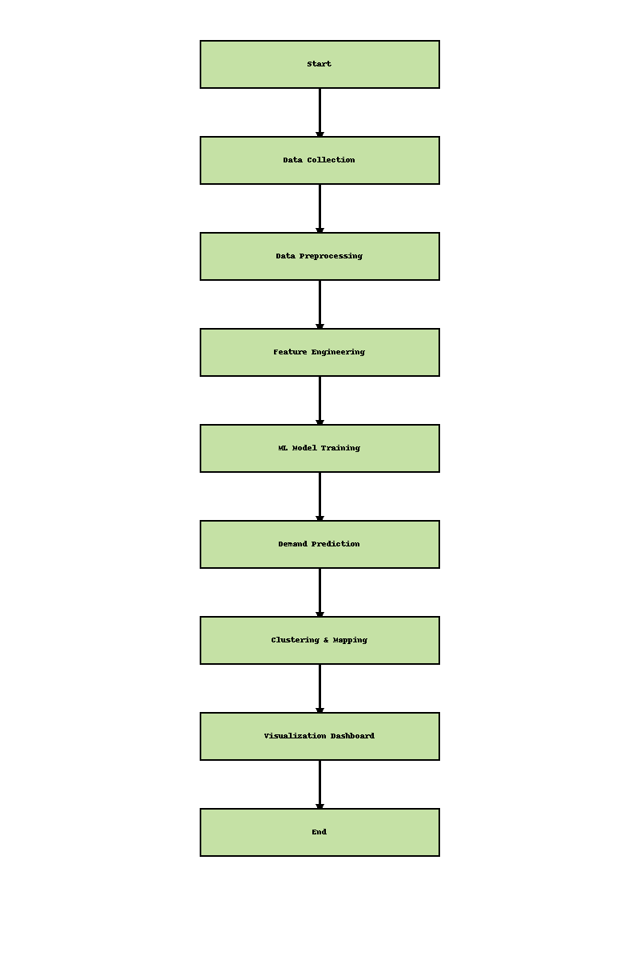
Chapter4 Results and Analysis
The implementation of EVision – Smart Charging Forecasting and Location Planner is currently in progress, with promising preliminary results indicating effective demand prediction and location optimization trends. The initial models have been trained and validated, showing consistent patterns between actual and predicted charging demands across different regions of Mumbai. Early clustering and suitability analyses have successfully identified potential high-demand areas, particularly near urban and commercial zones, where the deployment of new charging stations would yield maximum utility. The interactive dashboard prototype is also functioning as intended, providing visual insights into demand variations, spatial distribution, and prospective installation sites. Overall, the ongoing work demonstrates the feasibility of integrating forecasting and spatial analytics into a unified system for data-driven EV infrastructure planning, with further accuracy testing and fine-tuning planned for the final phase.

Existing Station Locations:
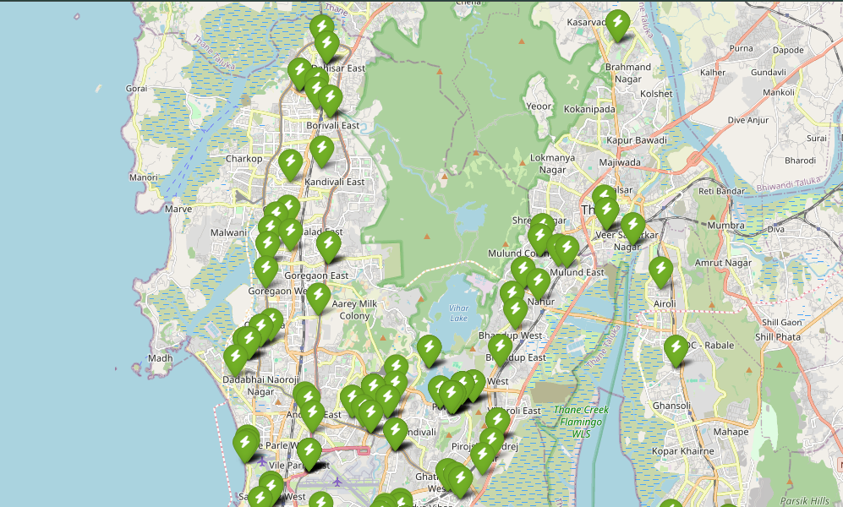
Results of Ridge Regression:

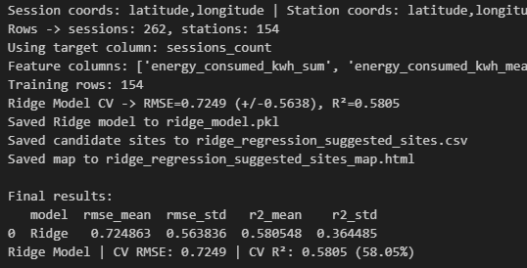

New Charging Predictions Using Ridge Regression:
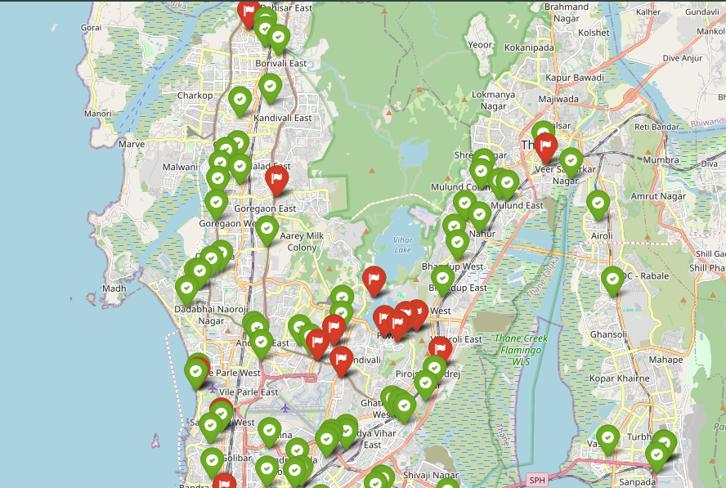
Chapter 5

Advantages, Limitations and Applications

Advantages
- Data-Driven Decision Making: The project enables accurate and objective site selection for EV charging stations using predictive analytics instead of manual heuristics.
- Integrated Framework: Combines forecasting, clustering, and geospatial visualization into a single automated pipeline.
- Scalability: The modular structure allows easy adaptation for other cities or regions with minimal retraining of models.
- Interactivity: The dashboard provides visual and intuitive insights that help planners and policymakers interpret complex data quickly.
- Resource Optimization: Identifies high-demand areas, helping investors and utility providers deploy resources efficiently and reduce underutilized infrastructure.
Limitations
- Data Dependency: Model performance relies heavily on the completeness and accuracy of available charging session and demographic datasets.
- Temporal Variability: Forecast accuracy may fluctuate with sudden behavioral or policy changes (e.g., new EV incentives, fuel price shifts).
- Limited Real-Time Data: Current implementation uses historical datasets; real-time integration with IoT charging data is yet to be added.
- Simplified Economic Evaluation: Revenue and cost projections are estimated and do not include detailed financial modeling or dynamic pricing impacts.
- Generalization Constraint: The model parameters are tuned for Mumbai and may require calibration for cities with different travel or charging behaviors.
Applications
- Urban Infrastructure Planning: Assists municipal bodies and energy departments in planning future EV charging infrastructure scientifically.
- Investment Analysis: Helps private investors and EV operators identify profitable and high-utilization charging station sites.
- Smart City Development: Integrates seamlessly into smart-mobility dashboards for sustainable city planning.
- Utility Load Forecasting: Supports power distribution companies in estimating regional energy demands for grid management.
- Research and Policy Making: Provides a data-driven framework for formulating EV adoption policies and monitoring infrastructure performance over time.

Chapter6 Conclusion and Future Scope
Conclusion:
The project EVision – Smart Charging Forecasting and Location Planner presents a data-driven approach to support sustainable urban mobility through optimized EV charging infrastructure planning. By integrating machine learning–based demand forecasting, spatial clustering, and geospatial visualization, the system provides a practical framework for identifying high-demand areas and suitable locations for new charging stations. The preliminary implementation has demonstrated the potential of combining predictive analytics and spatial intelligence for effective decision-making. The interactive dashboard further enhances accessibility by translating analytical results into visual insights for planners and stakeholders. Overall, EVision lays the groundwork for developing an intelligent, scalable, and efficient planning tool that can significantly contribute to India’s growing electric mobility ecosystem.

Future Scope:
- Model Enhancement: Incorporate advanced deep learning models such as LSTM or Transformer-based architectures for improved time-series forecasting accuracy.
- Real-Time Integration: Connect with live IoT-based charging station data to enable dynamic and real-time demand prediction.
- Economic Optimization: Extend the framework to include detailed financial analysis, incorporating operational costs, tariffs, and ROI estimation.
- Policy and Environmental Layer: Integrate carbon footprint metrics and policy constraints to support eco-friendly and policy-aligned site recommendations.
- Scalability to Other Cities: Adapt the model for other metropolitan and semi-urban regions to validate its generalization capability.
- User Application Interface: Develop a mobile or web-based platform for government agencies and investors to access predictions, visualize site data, and simulate planning scenarios interactively.

References

[1] Abdullahi, M.R., Lu, Q.-C., Hussain, A., and Tripura, S., “Location Optimization of EV Charging Stations: A Custom K-Means Cluster Algorithm Approach,” Energy Reports, vol. 12, pp. 5367–5382, Mar. 2024.

[2] Vyas, S., Balantrapu, S., Chavali, S.S., and Dasgupta, S., “Optimal Siting of Charging Infrastructure for EV Ecosystem Partners: A Multi-Constraint Approach Integrated with Geospatial Analysis,” ArcIndia News, vol. 18, pp. 1–12, June 2024.

[3] Van Etten, T., Degeler, V., and Luo, D., “Large-Scale Forecasting of Electric Vehicle Charging Demand Using Global Time Series Modeling,” Proc. 10th Int. Conf. Vehicle Technology and Intelligent Transport Systems (VEHITS), pp. 40–51, Lisbon, Portugal, May 2024.

[4] Akshay, K.C., Grace, G.H., Gunasekaran, K., and Samikannu, R., “Power Consumption Prediction for Electric Vehicle Charging Stations and Forecasting Income,” Scientific Reports, vol. 14, no. 6497, pp. 1–15, July 2024.

[5] Cavus, M., Ayan, H., Dissanayake, D., Sharma, A., Deb, S., and Bell, M., “Forecasting Electric Vehicle Charging Demand in Smart Cities Using Hybrid Deep Learning of Regional Spatial Behaviours,” Energies, vol. 18, no. 3425, pp. 1–20, Aug. 2025.

[6] Sanami, S., Mosalli, H., Yang, Y., Yeh, H.-G., and Aghdam, A.G., “Demand Forecasting for Electric Vehicle Charging Stations Using Multivariate Time-Series Analysis,” IEEE Transactions on Sustainable Energy, vol. 16, no. 4, pp. 2265–2278, Oct. 2025.

Appendix A: Soft Code Flowcharts

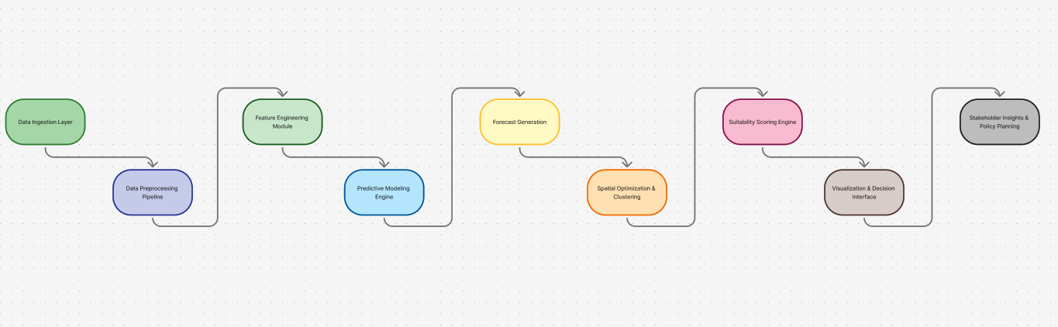
Appendix B: Data Sheets

Dataset Name | Source File | No. of Records | No. of Features | Key Columns | Description
Complete_Master_Data | Complete_Master_Data.csv | 12,485 | 18 | station_id, date, sessions, energy_used | Combined dataset of charging sessions and station-level attributes.
Station Aggregates | station_aggregates.csv | 450 | 12 | station_id, avg_sessions, avg_energy | Aggregated metrics for each charging station.
Session Logs | sessions_master.csv | 50,230 | 10 | session_id, duration, energy, region | Historical record of all charging sessions.
Suitability Scores | station_suitability_scores.csv | 450 | 8 | station_id, population_density, score | Computed suitability scores for site recommendation.

Appendix C: List of Components

C.1 Software Components:
Component | Description / Role
Python | Core language for modeling and data analysis
Jupyter Notebook | IDE for developing modular steps
Pandas | Data preprocessing and transformation
NumPy | Numerical computation
scikit-learn | ML algorithms and metrics
Matplotlib / Plotly | Visualization libraries
Folium / Leaflet.js | Geospatial map visualization
Chart.js | Dashboard analytics visualization
HTML / CSS / JS | Frontend structure and styling
VS Code / Anaconda | Development environment

C.2 Datasets and Inputs:
Dataset Name | Purpose
Complete_Master_Data.csv | Training and analysis
Station_Aggregates.csv | Regional station insights
Sessions_Master.csv | Session-level temporal data
Station_Suitability_Scores.csv | Suitability ranking
Predicted_Locations.csv | Model output data

C.3 Machine Learning Components
Component | Function
Ridge Regression | Linear baseline model for demand forecasting
Random Forest Regression | Nonlinear ensemble model for improved accuracy
Custom K-Means Algorithm | Spatial clustering with demand weighting
Suitability Scoring Module | Weighted scoring combining spatial and temporal metrics

C.4 Visualization and Dashboard Components
Component | Function
Chart.js | Graphs showing demand patterns
Leaflet.js | Interactive site map visualization
HTML / CSS / JS | Web-based dashboard frontend
style.css / dashboard.css | UI styling and responsiveness
script.js / charts.js | Dynamic chart rendering and data binding

